**Problem P2-19 (Applying overhead to projects/products)**

High Desert Potteryworks makes a variety of pottery products that it sells to retailers such as Home Depot. The company uses a job-order costing system in which predetermined overhead rates are used to apply manufacturing overhead cost to jobs. The predetermined overhead rate in the Molding Department is based on machine-hours, and the rate in the Painting Department is based on direct labor-hours. At the beginning of the year, the company's management made **the following estimates**:

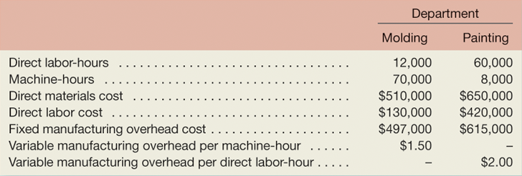

Job 205 was started on August 1 and completed on August 10. The company's cost records show the following information concerning the job:

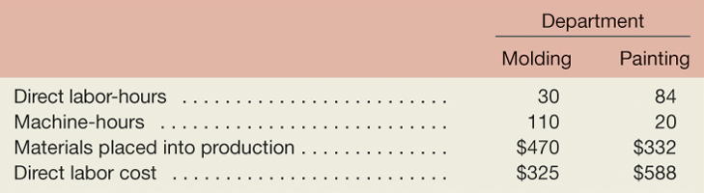

***Required:***

1. Compute the total overhead cost applied to Job 205 and the total cost recorded for Job 205.
2. At the end of the year, the records of High Desert Potteryworks revealed the following actual cost and operating data for all jobs worked on during the year:

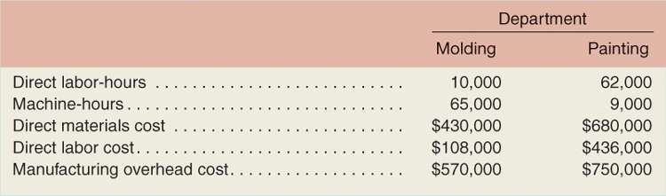

What is the amount of under-applied or over-applied overhead in each department?

**(Please write down your answers on the backside of this worksheet)**

**Your answers:**